Conference 2023
Codes and Links to share the conference on Social Media
Media | Code or Link
Conference 2023 Flyer jpg  *see next page | https://drive.google.com/file/d/1gz80ZJTbJxW2BK9c1Vm7JkXK6aVV36ts/view?usp=sharing
Conference 2023 Flyer png | https://drive.google.com/file/d/1rHlBEzyPhSNox2p5rRGGincm1P8z65mY/view?usp=sharing
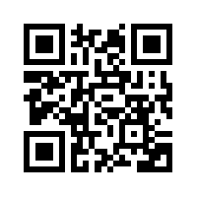  Conference 2023 speakers  Slides Presentation: | https://docs.google.com/presentation/d/1r-rYkAuJQwADvU1j_lygVzHjxZOLiBGZ5X2f4_k3Bnk/edit?usp=sharing
Conference 2023 speakers:  Animoto Video | https://animoto.com/play/02zf948nXGLaXpInvH073A
Video: Conference 2023 Speakers | Code to embed on website  <iframe id="vp102zf9" title="Video Player" width="432" height="243" frameborder="0" src="https://s3.amazonaws.com/embed.animoto.com/play.html?w=swf/production/vp1&e=1677986577&f=02zf948nXGLaXpInvH073A&d=0&m=a&r=360p+480p&volume=100&start_res=undefined&i=m&asset_domain=s3-p.animoto.com&animoto_domain=animoto.com&options=" allowfullscreen></iframe>

