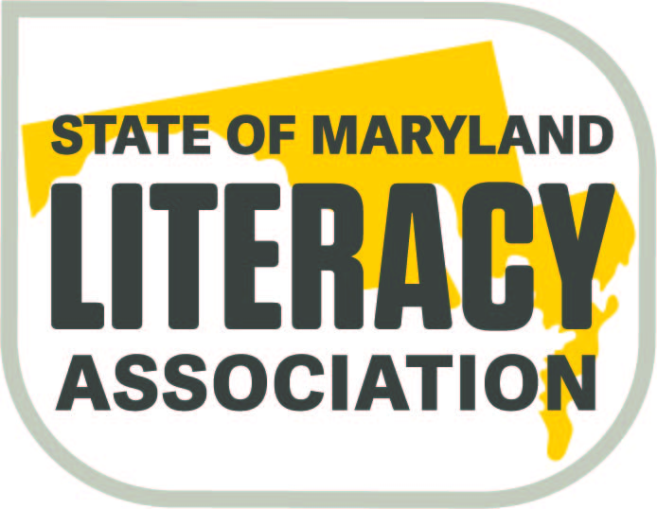

SoMLA

The State of Maryland Literacy Association (SoMLA formerly SoMIRAC) is a professional literacy organization. Membership includes teachers, administrators, instructional assistants, university professors, college students, parents, and community members.

Mission

SoMLA will empower educators, inspire students, advocate for literacy, and encourage leaders with resources they need to make literacy accessible for all.

Purpose

- We promote cutting-edge research translated into practical resources for educators and students; adhere to ILA standards for literacy professionals and teacher education programs; disseminate knowledge helpful in the solution of problems related to literacy; appreciate educators through rewards and grants; and vigorously advocate for funding and policies supporting the literacy needs of school systems, teachers, and students throughout the state.
- Literacy is our cause, our passion, and our reason for being. Why? Because every day we see its power to transform people’s lives: developing their potential, earning their livelihoods, participating fully in their communities and society, and enjoying the fullness that continuous learning brings to their lives.
- With the collective support of our members, our worldwide community of literacy practitioners, and our partners, our team aspires to create an Age of Literacy in which this transformative power is accessible to everyone.

