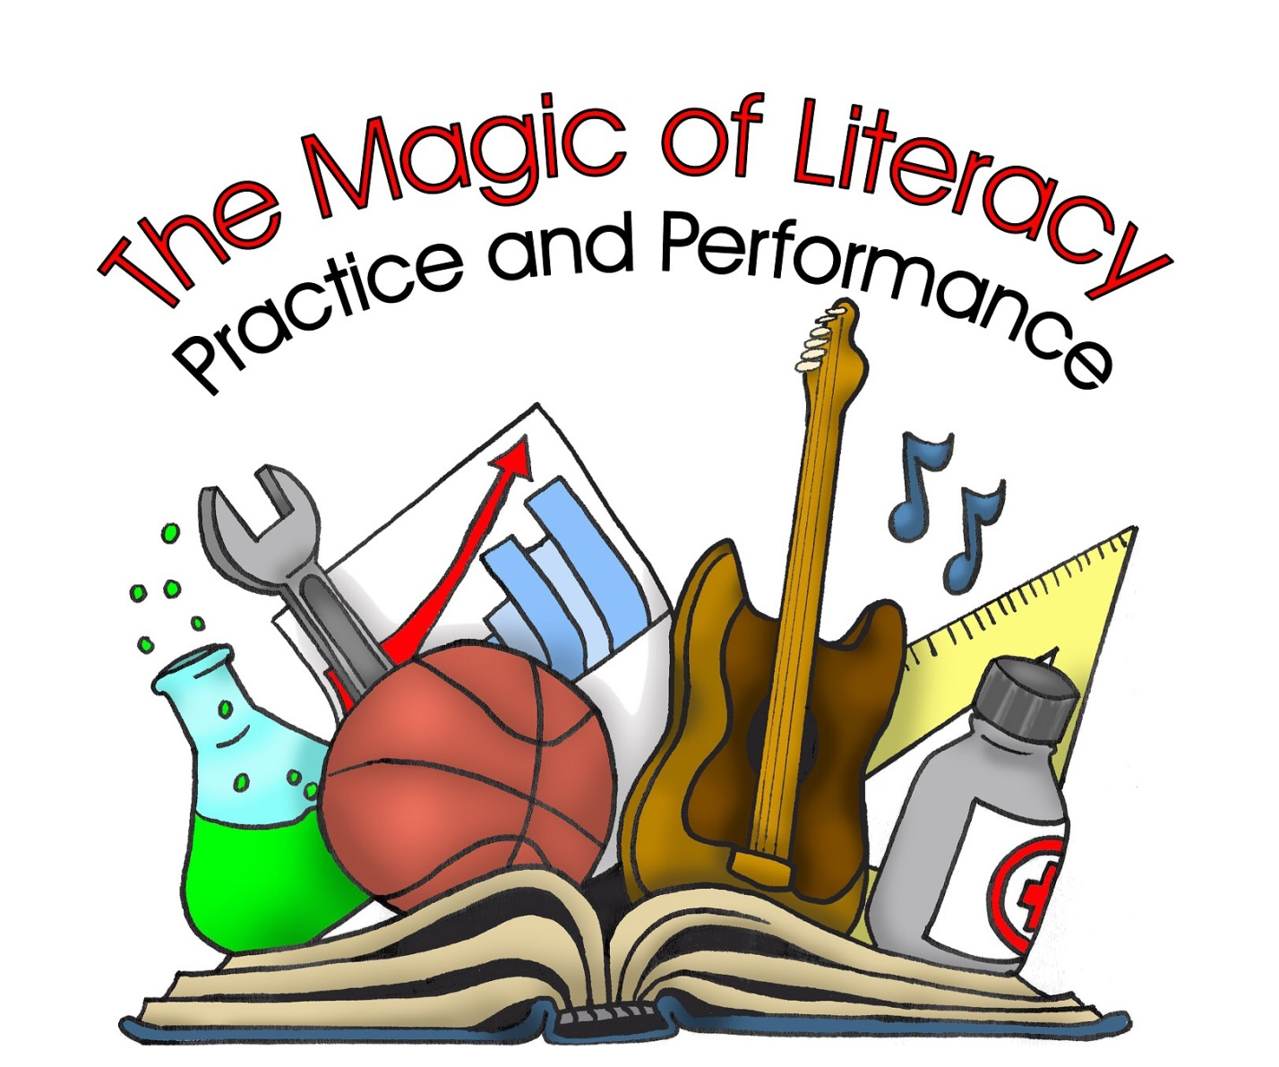

State of Maryland
International Reading Association Council

Forty-fourth Annual Conference

April 6-8, 2016
Hunt Valley Inn
Baltimore, Maryland

General Information

- The 44rd Annual State of Maryland International Reading Association Council (SoMIRAC) Conference will be held April 6-8, 2016 at the Hunt Valley Inn Baltimore, 245 Shawan Road, Hunt Valley, MD 21031.

- Conference theme is _______________________

- Concurrent sessions will be sixty minutes in length

- Proposals for concurrent sessions must be received by October 31, 2015.

Presenters must be current (2015-2016) members of a local reading council which includes membership in SoMIRAC. If you are not a member your proposal may not be considered for this year’s conference.

- ALL PRESENTERS ARE EXPECTED TO REGISTER AND PAY ALL CONFERENCE FEES BY JANUARY 31, 2016. FAILURE TO REGISTER BY THIS DATE MAY RESULT IN THE CANCELLATION OF THE PRESENTER’S SESSION.

- As a professional, nonprofit organization, SoMIRAC is unable to reimburse concurrent session presenters for travel, honorarium, and/or hotel expenses.

Guidelines for Proposals

- Each proposal must include the completed application form and attachments included in this brochure with, if applicable, a list of additional presenters with complete addresses, phone numbers, and email addresses. ALL PRESENTERS MUST BE MEMBERS OF SOMIRAC, REGISTER FOR THE CONFERENCE, AND PAY FULL CONFERENCE FEES.

- The person submitting the proposal must receive advance consent from each additional presenter.

- The person submitting the proposal is responsible for sharing membership and registration information with co-presenters.

- A chairperson/facilitator will be provided for each session.

* NO AUDIVISUAL EQUIPMENT WILL BE PROVIDED

One screen and one overhead will be
provided in each room.

Any additional audiovisual equipment, including an LCD projector, must be provided by the presenter.
A SCREEN WILL BE PROVIDED FOR EACH ROOM

One screen and one overhead will be
provided in each room.

Any additional audiovisual equipment, including an LCD projector, must be provided by the presenter.

One screen and one overhead will be
provided in each room.

Any additional audiovisual equipment, including an LCD projector, must be provided by the presenter.
Topic Suggestions

- Emergent/Early Literacy
- Primary/Intermediate Literacy
- Adolescent Literacy
- The Middle School Reader
- High School Literacy
- Curriculum Integration
- Differentiating Instruction
- Best Practices for Instruction
- Comprehensive Literacy Program
(Phonemic Awareness, Phonics, Fluency,
Vocabulary, and Comprehension)
- Family Literacy
- Title I
- Maryland Curriculum
- Maryland State Assessments
- Multicultural Education
- English as a Second Language
- Closing the Achievement Gap
- Struggling Readers/Reading Intervention
- Literacy Coaching
- Literacy Data Analysis
- Library Media and Classroom Connections
- Content Area Reading/Nonfiction Text
- The Writing Process
- Technology and Literacy
- Common Core Curriculum Standards
- Building the Administrator’s Role in Literacy Instruction

Applicants submitting proposals will be notified by email as to acceptance or non-acceptance by December 1, 2015.

Proposals will not be returned. Please make copies.

Direct all questions to
Bonnie Schmeltz:

Phone: 301-725-4886 (H)
301-792-9156 (C)
E-Mail:
beareader50@gmail.com

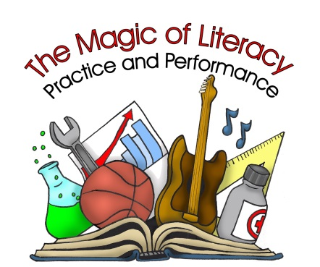

Concurrent Session Proposal Form
Submission Deadline: October 31, 2015
SoMIRAC 2016 Conference: April 6-8, 2016

Title of Presentation: _______________________________________________

Name(s) of Presenters: (4 maximum)
________________________________________________
________________________________________________
________________________________________________
________________________________________________

Program description as desired for conference program: (25-30 word limit) __________________________________________________________________________________________________________________________________________________________________________________________________________________________________________

Grade Level Match: Target Audience: Check all that apply.
____ Birth to Pre-K ____ K-2 ____ Classroom Teacher ____ Reading Specialist
____ 3-6 ____ 5-8 ____ Administrator ____ Title I ____ 8-12 ____ Intervention Teacher ____ Special Educator

Person Submitting Proposal:

Name_______________________________________________ Title/Position:____________________
Mailing Address: _______________________________________________________________________ ____________________________________________________________________________________
Telephone: (Home) _______________________________ (Work) _______________________________
E-mail: _________________________________________ (FAX) ________________________________
School System and School: _______________________________________________________________ Have you ever presented at a SoMIRAC Conference? No _____ Yes_____ Year _________
I am a member of _______________________________________________ (local) Reading Council.

**NO AUDIOVISUAL EQUIPMENT WILL BE PROVIDED
Presenters must provide their own laptops, LCD projectors, speakers, and other audiovisual equipment. Screens will be provided for each room.

Names, Titles, Home Addresses, Email Addresses and Phone Numbers of Additional Presenters in Group. All presenters must be 2015-2016 members of a local reading council and must register and pay for the conference prior to JANUARY 31, 2016.

1. __________________________________________________________________________________________
__________________________________________________________________________________________
__________________________________________________________________________________________
2. __________________________________________________________________________________________
__________________________________________________________________________________________
__________________________________________________________________________________________
3. __________________________________________________________________________________________
__________________________________________________________________________________________
__________________________________________________________________________________________
4. __________________________________________________________________________________________
__________________________________________________________________________________________
__________________________________________________________________________________________

Program Abstract (attachment):

In a brief outline or description of approximately 200 words, address the following points. These will be used for evaluation of your presentation by the conference program selection committee.

A. Objectives of the Session D. Organization of Time for Presentation
B. Highlights of Content E. Each Presenter’s Responsibility
C. Presentation Methods F. Audience participation

Information for Session Chairpersons (attachment):

Attach a brief biography of all speakers for use during introductions to session presentations.

Please email concurrent proposal form to Bonnie Schmeltz
at beareader50@gmail.com

